Preparation of the Full Paper for 2022 International Conference on Machining, Materials and Mechanical Technologies (2022 IC3MT) using Arial 14

FULL First Author1, a \***,** FULL Second Author2,b and FULL Last Author3,c

1Full address of first author, including country

2Full address of second author, including country

3List all distinct addresses in the same way

aemail, bemail, cemail

* Please mark the corresponding author with an asterisk

**Keywords:** International conference on progress machining technology, full paper formatting guidelines, deadline

***For the rest of the paper, please use Times Roman (Times New Roman) 12***

**Abstract.** The conference will be held at Main Campus II of National Taiwan Normal University, Taipei, August 19 - 23, 2022. The contributors should write their abstract with keywords according to the paper formatting guidelines and save it into MS-WORD format. Abstracts should be submitted via the IC3MT website and marked with the relevant themes. The deadline for abstract submission is *April 08, 2022.* Authors of accepted abstracts are required to prepare an Extended Abstract or a Full Paper according to a specified camera-ready format. The submitted extended abstracts and full papers will be reviewed, and only the outstanding full papers are expected to be published in the journal (*Trans Tech Publications*) further. The format of the *full paper* is as follows.

Introduction

The conference will be organized by National Central University and held on August 19–August 23, 2022. There will be three main topics as listed below:

1. Machining technology

2. Materials technology

3. Mechanical technology

Please make the page settings of your word processor to A4 format (21 x 29.7 cm); with the margins: bottom 1.5 cm and top 2.5 cm, right/left margins must be 2 cm.

Use *italic* for emphasizing a word or phrase. Do *not* use boldface typing or capital letters except for section headings (cf. remarks on section headings, below).

The paper page number shall be *6~8 pages*. The contributors should follow the instruction on the web page http://ic3mt2022.conf.tw and upload the file.

Organization of the Text

**Section Headings.** The section headings are in boldface capital and lowercase letters. Second level headings are typed as part of the succeeding paragraph (like the subsection heading of this paragraph).

**Page Numbers.** Do *not* number your paper.

**Special Signs**. For example, *α* *γ* *μ* *Ω* () ≥ ± ● Γ {110} should always be written in with the fonts Times New Roman or Arial, especially also in the figures and tables.

**Macros**. Do not use any macros for the figures and tables. (We will not be able to convert such papers into our system)

**Language**. All manuscripts must be in English, also the table and figure texts; otherwise, we cannot accept your paper.

**Table and figure**

**Tables.** Tables (refer with: Table 1, Table 2, etc.) should be presented as part of the text, but in such a way as to avoid confusion with the text. A descriptive title should be placed above each table. Units in tables should be given in square brackets [meV]. If square brackets are not available, use curly {meV} or standard brackets (meV).

Table 1　Dates and place for the conference

|  |  |
| --- | --- |
| Date | August 19-23, 2022 |
| Place | Main Campus II of National Taiwan Normal University, Taipei |

**Figures.** Figures (refer with: Fig. 1, Fig. 2, etc.) should be presented as part of the text, leaving enough space so that the caption will not be confused with the text. The caption should be self-contained and placed *below* the figure. Generally, only original drawings or photographic reproductions are acceptable. Only very good photocopies are acceptable. Utmost care must be taken to *insert the figures in correct alignment with the text*. Half-tone pictures should be in the form of glossy prints. If possible, please include your figures as graphic images in the electronic version. For best quality, the pictures should have a resolution of 300 dpi (dots per inch).

Color figures are welcome for the online version of the journal. Generally, these figures will be reduced to black and white for the print version. Authors should indicate on the checklist if they wish to have them printed in full color and make the necessary payments in advance.

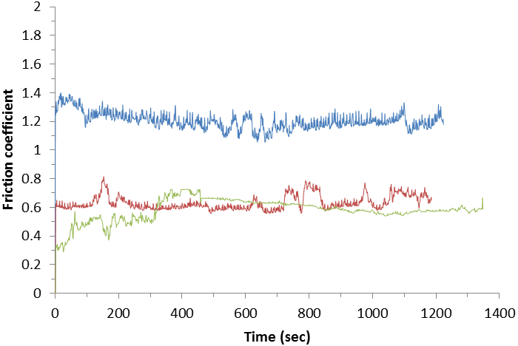

Fig.1　Friction coefficients of various samples when sliding against Ti6Al4V

**Equations.** Equations (refer with: Eq. 1, Eq. 2, etc.) should be indented 5 mm. There should be one line of space above the equation and one line below it before the text continues. The equations have to be numbered sequentially, and the number put in parentheses at the right-hand edge of the text. Equations should be punctuated as if they were an ordinary part of the text. Punctuation appears after the equation but before the equation number. The use of Microsoft Equation is allowed.

*c*2 = *a*2 + *b*2 (1)

 (2)

Literature References

References are cited in the text just by square brackets [1]. Two or more references at a time may be put in one set of brackets [3, 4]. The references are to be numbered in the order in which they are cited in the text and are to be listed at the end of the contribution under the heading *References*; see our example below.

Summary

If you follow the “checklist,” your paper will conform to the requirements of the publisher and facilitate a problem-free publication process.

Important dates

Please submit the full paper followed the instruction on the website: <http://ic3mt2022.conf.tw>

April 08 2022: Deadline for abstract

May 06 2022: Notification of acceptance

June 03 2022: Deadline for the manuscript in PDF

July 01 2022: Notification of manuscript acceptance

Footnotes

The contributors should convert their articles into PDF format, and the size of the file should not exceed 2MB. If you have any questions, contact Prof. Yu-Ren Wu by e-mail: yurenwu@ncu.edu.tw

If you need any information about the annual conference, please consult the conference website: http://ic3mt2022.conf.tw

Acknowledgments

If a treasury sponsored the paper, please acknowledge the financial support. For example, provide the ID number of the project if it was supported by Taiwan Ministry of Science and Technology (MOST110-XXXX-XXXX-XX).

References

[1] J. van der Geer, J.A.J. Hanraads, R.A. Lupton, The art of writing a scientific article, J. Sci. Commun. 163 (2000) 51-59.

Reference to a book:

[2] W. Strunk Jr., E.B. White, The Elements of Style, third ed., Macmillan, New York, 1979.

Reference to a chapter in an edited book:

[3] G.R. Mettam, L.B. Adams, How to prepare an electronic version of your article, in: B.S. Jones, R.Z. Smith (Eds.), Introduction to the Electronic Age, E-Publishing Inc., New York, 1999, pp. 281-304.

[4] R.J. Ong, J.T. Dawley and P.G. Clem: submitted to Journal of Materials Research. (2003)

[5] P.G. Clem, M. Rodriguez, J.A. Voigt and C.S. Ashley, U.S. Patent 6,231,666. (2001)

[6] Information on http://www.weld.labs.gov.cn